**STRATEGIC MANAGEMENT**

**Group Project**

**Group 2 | SIBM-B (BA) | Batch 2020-22**

Aastha Joshi, 20020845001 | Balaji K, 20020845006 | Joel Keith Pais, 20020845011  
Rohan Nisale, 20020845018 | Taksande Sandeep Ravindra, 20020845030

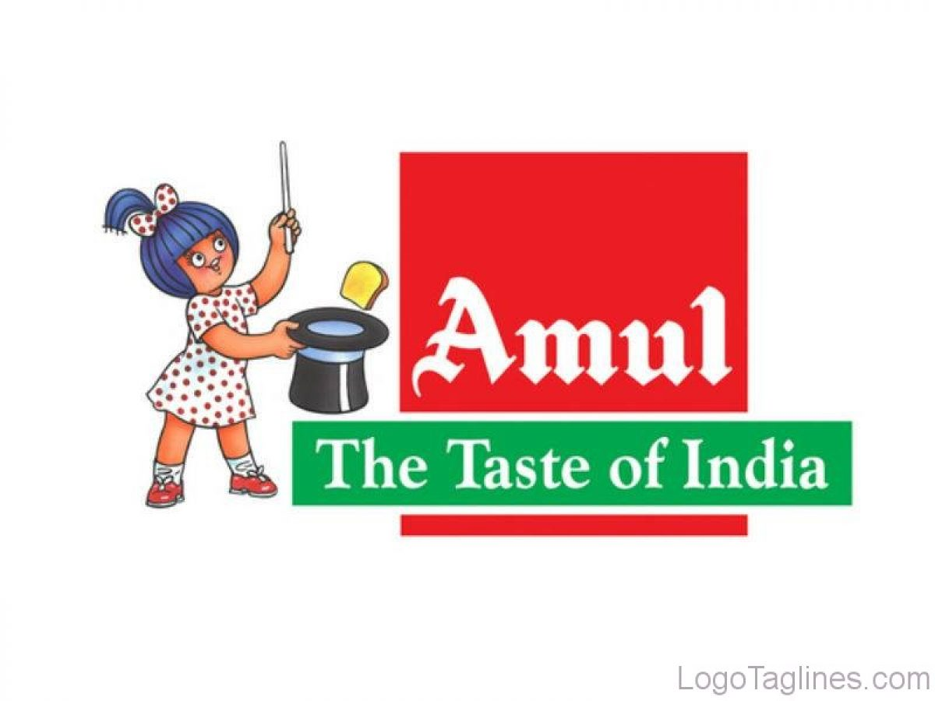

## **INTRODUCTION**

Amul was founded in 1946 by Tribhuvandas Patel, Verghese Kurian and has its headquarters in Anand, Gujarat. It has an annual turnover of INR 29,220 Crores (2018) and has approximately 3.6 Million employees. The current CEO of Amul is Mr. R.S. Sodhi. The AMUL acronym stands for ‘**Anand Milk Union Limited**’. It is a cooperative brand managed by Gujarat Cooperative Milk Marketing Federation, a cooperative body. The body is jointly owned by 3.6 million milk producers located in Gujarat and an apex body of 13 District Milk Unions spread across 13000 villages. It was awarded the Rajiv Gandhi National Quality Award in the year 1999. The establishment of Amul is considered to be the “**White Revolution”.**

Amul’s chocolate plant in Mogar has increased the capacity from 250 tons per month to 1000 tons per month. Amul is currently the largest manufacturer of milk and dairy products in India. The country considers Amul to be a national brand due to its presence. It is widely used and accepted all over the country. The origin of Amul is meant to protect the interest of an Indian Consumers and Producers.

## **VISION**

Amul's vision is to provide more and more satisfaction to the farmers, employees, and distributors.

## **MISSION**

We at Gujarat Cooperative Milk Marketing Federation (GCMMF) endeavor to satisfy the taste and nutritional requirement of the customers of the world, through excellence in marketing by our committed team. Through co-operative networking, we are committed to offering quality products that provide best value for money.

## **SWOT ANALYSIS**

### Strengths:

1. **Market Leader** - Amul has established itself as a market leader in India due to the organized ice cream sector with a market share of 1/3. The ice cream industry is expected to grow by 30% in the coming years, and its dairy and cheese products are expected to grow by more than 20%.
2. **Brand Recall and Equity** - Amul has become a favorite of many Indians because of its Amul children's art campaign that evokes beauty and emotion all the time. It has strengthened Amul’s brand awareness especially when it comes to brand recall and equity. There are only a few types of dairy-based products available with the same public image as Amul in India

### Weaknesses:

1. **Operating Expenses** - Amul operating costs are enormous due to its massive structure. This becomes a debt to the company as Amul undergoes price fluctuations and relies on its agricultural unions and a society whose daily needs are growing. Amul does not have an effective way to deal with these challenges given the unpredictability of supply.
2. **Portfolio Expansion** - Amul has diversified its various dairy products, but has never experienced similar success in some of its products. A good example is its chocolate products, which have not yet reached the same level of success as its ice cream. Amul’s portfolio expansion is important to its brand image.

### Opportunities:

1. **International Markets** - Amul has the ability to explore its access to international markets. It can reach many Asian markets, from neighboring countries to other regions and operate efficiently. Its exports will increase margins and their turnovers in a faster way.
2. **Chocolate Production** - Amul can invest freely in its chocolate production and succeed in the chocolate business. With enough advertising, it could be the biggest thing

### Threats:

1. **Growing Competition** - Amul is increasingly facing stiff competition in the Ice Cream sector. More and more local and foreign companies are attacking their markets and getting their sales. Competitors such as Kwality Walls, Mother Dairy, Basin Robbins, London Milk and Havmor are just a few of the names that directly threaten its business.
2. **Negative Media Coverage** - Negative media coverage did not benefit Amul's performance. It affected its sales and forced them to issue statements leading to unwanted media attention.

## **BUSINESS MODEL**

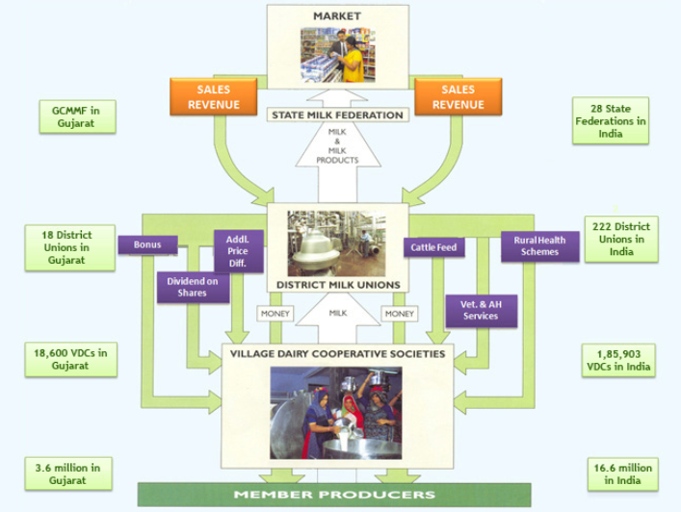

### Business Level Strategies

Amul has used a **cost leadership strategy** to expand the market share by focusing on the middle class which is the largest segment of the overall customer market in majority of the countries. This segment of customers generally prefers a lower price and hence cost leadership is the best strategy to fulfil their needs and entice these customers. The low prices are possible due to maximization of its supply chain and low cost of production. Amul uses discounts and coupons as means to achieve high sales and unburden the pressure from competitors. Being a cost leader has helped in increasing customer count and reach by spotlighting on affordability and accessibility.

The organization has also made use of **differentiation strategy** along with their cost leadership strategy to achieve sustainable competitive advantage. Amul used this strategy to innovate and address the customers’ needs. For example, Amul has expanded its product line after doing an in-depth study on changing consumer demands to help in differentiating from the competition and further expand its operations. A sizable amount of investment has also been made in the marketing front and in research and development to attract customers.

Amul has also utilized a **focus strategy** to serve needs of a niche customer segment at an affordable price.

### Corporate Level Strategies

The company has used **market penetration strategy** to improve their sales target by reducing the prices of the products through cost leadership. This has helped Amul in increasing customers in a saturated market.

**Product development strategy** is helpful in attracting more customers and Amul has used this as a form of differentiation strategy to improve upon existing products and offer unique products and expand the customer base in existing segments. Cost leadership has also helped in this by optimizing infrastructure costs for launching novel commodities.

Amul has used **market development** as a form of expansion and growth strategy to enhance its scale of operations. The brand’s good cultural know-how has helped it to reach diverse consumer markets in different parts of the world.

Amul has used a related **diversification strategy** while leveraging its strong brand awareness to expand its portfolio in the beverage industry overseas. Examples of unrelated diversification products like refrigerators, stationery etc. Another example is, when Amul was facing criticism from environmental protection groups, it set out to diversify in green businesses and partnering with businesses with a positive brand image.

### Functional level strategies

**Supply chain or Operational Strategy**

**Distribution Network:**

Amul Products are available in 5,00,000 retail outlets throughout the Indian subcontinent. It has 3,500 distributors and 47 depots with dry and cold warehouses in order to buffer the inventory for the entire range of products.

Wholesale dealers carry inventory that's just capable of the transit time from the branch warehouse to their premises. **Just-in-time inventory strategy** is being followed where the dealers will carry inventories / products from the warehouse to the distributing units.

All GCMMF branches engage in route scheduling and have dedicated vehicle operations.

GCMMF have their own processing plants in Haryana, Uttar Pradesh, Maharashtra, Madhya Pradesh, West Bengal and Rajasthan. Milk processed from other states will be processed here.

**The Cooperative Model to manage Supply chain or operations:**

GCMMF is **a cooperative society model** where people or in this case [farmers (milk producer)] of the village are the members of the cooperative society & come together and pool their resources. So, they are called members of this model.

These people take care of the resource operations and finances of the enterprise and follow the concept of “**Unity is strength**” where if one does not have the expertise or capital to expand together as a group, the cooperative members will help in raising the capital which is needed.

The channel structure is **5 stage structure** (**flow of products**)

**Farmer --> village cooperative --> district cooperative society --> State Milk Federation -> Consumers**

* Farmers who are part ofthe **village cooperative union** produce the milk and send it to the district cooperative society / union
* This **district cooperative union** will in turn **process the milk products** into various by-product such as ghee, cheese, butter, sweet, ice-creams & condensed milk & **finally packaging**
* This in turn is sent to the **state milk federation who acts like a distributor**. The **cash flow will happen in the opposite direction of the product flow from the state milk federation** (distributor) to farmers.
* So, there is an **elimination of middle men** there by the **buying cost for the milk federation gets reduced which leads to high profit margin.**

**Finance strategy**

* The revenue that state milk federation generate from selling the products will be given back to the district cooperative union which in turn provides it to the farmers
* Since farmers are the members of the village cooperative union. GCMMF consider the village union as a subsidiary of district mil unions & issues the dividends , bonus for its members
* On the other hand, they help farmers (members of the cooperative) with all the necessaries such as cattle feed, veterinary, rural health schemes for the family.
* Thereby they create unique bond or relation with the families of farmer which in turn bears the fruit by procuring the required milk from them at low cost

**Marketing strategy**

**Brand promotion (or) Advertising strategy**

To promote their brand, they took the help of AS Advertising company where they came up with an idea of a **little polka dot girl (Mascot / character)** to promote their products. Later, they went ahead to use the character in the newspaper just to promote their products as well as have a theme about the latest news in a humorous way.



Apart from that they have a Tagline **“TASTE OF INDIA”**. They followed the **branded house strategy** which basically means **marketing all of its products under a single brand name AMUL** similar to what Patanjali is doing currently. This branded house strategy was very efficient and thereby reduced its advertising cost to merely one percent of its revenue.

**Innovation Strategy**

Nestle **milk powder** was very popular during the 1950’s and **could be processed only from cow’s milk**. Since **Nestle,** being **a European company,** **used cow’s milk powder**, the **technology to extract milk powder from buffalo milk was not invented**. But on the other hand, **India had more buffalos** so Dr. Verghese Kurain along with diary engineer (H M DALAYA) and AMUL invented the process of **extracting milk powder from buffalo milk** which caused Amul to overtake Nestle as a market leader and knocked them down from the competition in terms of milk products.

### Global Strategy

Amul was the first company from India to become a multinational cooperative. To promote them on a global level they sponsored the New Zealand cricket team for the Champions Trophy in England as they were well known for their dairy product exports. Today, Amul is available in over 40 countries across the world, exporting a wide variety of products. The major markets are the USA, West Indies, African countries, The Gulf region and our SAARC neighbours (Singapore, The Philippines, Thailand, Japan and China)

They are in the top 20 global milk processors. They follow the concept of economies of scale before exporting the products as the manufacturing costs in India is low

**EVALUATION OF BUSINESS MODEL**

The Amul Model of dairy development is a three-tiered structure linked with the dairy cooperative societies at the village level. The model comes under a federation of member unions at the state level and a milk union at the district level. The business model of Amul is quite unique and this has helped it to retain its market leader status since its inception. Amul is a cost leader with a strong focus on customer’s needs. It has utilized its differentiation strategy efficiently by constantly innovating, improving its products, introducing better quality and lower price commodities than their competitors. Amul has used various growth strategies to expand its operations both in India as well as overseas. The success of Amul as a global brand is a testament of its efficient use of resources and strategies.

## **CONCLUSION**

Amul has a wide range of product portfolios and has dominated every single market it has stepped into with an exception of the chocolate industry. It had introduced the ‘Amul Chocolate bar’ but failed to impress the consumers. The chocolate industry is a highly profitable market and Amul should revise its growth strategy in this sector by coming up with new promotional activities/campaigns to increase its market share.

Amul has also come under pressure with the arrival of major retail brands like Walmart which is threatening to undermine Amul’s existing supply chain and low-cost product pricing structure. Amul needs to revamp its business and functional strategies to tackle this.

## **REFERENCES**

* <https://www.hbs.edu/faculty/Pages/item.aspx?num=51103>
* <https://www.amul.com/m/about-us#:~:text=The%20Amul%20Model%20of%20dairy,unions%20at%20the%20state%20level>.
* <https://blog.finology.in/investing/amul-business-model-verghese-kurien>
* <https://bstrategyhub.com/swot-analysis-of-amul-2019-amul-swot-analysis/>
* <https://blog.finology.in/investing/amul-business-model-verghese-kurien>
* <https://www.quora.com/How-does-the-business-model-of-AMUL-work>
* <https://www.amul.com/m/about-us#:~:text=The%20Amul%20Model%20of%20dairy,unions%20at%20the%20state%20level>.
* <https://youtu.be/vqkciGKC7Lo>
* https://www.rediff.com/business/report/amul-from-taste-of-india-to-taste-of-the-world/20170621.htm